
University of jordan
School of engineering
Mechanical department

Strength Lab Report
Experiment #4
“Creep Test”

Introduction :
Creep is high temperature progressive deformation at constant stress. "High temperature" is a relative term dependent upon the materials involved. Creep rates are used in evaluating materials for boilers, gas turbines, jet engines, ovens, or any application that involves high temperatures under load. Understanding high temperature behavior of metals is useful in designing failure resistant systems. A creep test involves a tensile specimen under a constant load maintained at a constant temperature. Measurements of strain are then recorded over a period of time.
Creep occurs in three stages: Primary, or Stage I; Secondary, or Stage II: and Tertiary, or Stage III. Stage I, or Primary creep occurs at the beginning of the tests, and creep is mostly transiently, not at a steady rate. Resistance to creep increases until Stage II is reached. In Stage II, or Secondary creep, The rate of creep becomes roughly steady. This stage is often referred to as steady state creep. In Stage III, or tertiary creep, the creep rate begins to accelerate as the cross sectional area of the specimen decreases due to necking or internal voiding decreases the effective area of the specimen. If stage III is allowed to proceed, fracture will occur.

Objectives :
To obtain the plot of creep strain growth as a function of time
Rate of deformation is a function of:
- Applied load
- Exposure temperature
- Exposure time
- Material properties

Procedure :
The creep test is conducted using a tensile specimen to which a constant stress is applied, often by the simple method of suspending weights from it. Surrounding the specimen is a thermostatically controlled furnace, the temperature being controlled by a thermocouple attached to the gauge length of the specimen, Fig.2. The extension of the specimen is measured by a very sensitive extensometer since the actual amount of deformation before failure may be only two or three per cent. The results of the test are then plotted on a graph of strain versus time to give a curve similar to that illustrated in the figure next page.

Apparatus :
Creep testing machine :
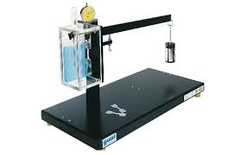
Figure 1

Specimen : 25mm gauge length
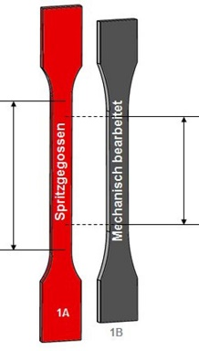
Figure 2

Theory :
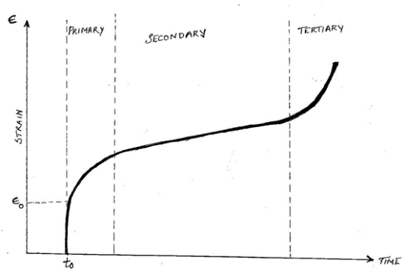
Figure 3

The diagram above shows strain as a function of time. The portions are split as primary, secondary and tertiary curve. In the beginning, the rate of strain is high and then stabilizes due to work hardening. In the second segment, the strain is minimum and nearly constant which happens as a result of balance between annealing and work hardening. The tertiary segment is similar to the necking phenomenon observed when metals are tension tested in Universal testing machine.
The strain vs. time graphs are plotted with a constant load applied at a constant temperature. Shape of the creep curve will depend on the levels of temperatures and stresses involved. If the temperature is remained constant, the creep curves will shift upward and to the left with increasing applied stresses. If the creep test is carried out at various temperatures but at a constant stress level, the creep rate will increase with increasing temperatures.
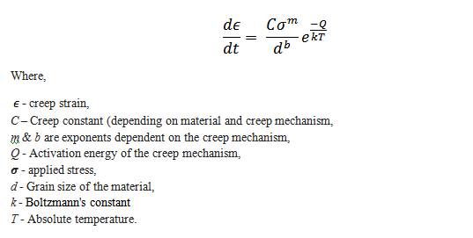

The deformation process in creep which occur at elevated temperatures are due to
- Dislocation movement known as slip
- Grain boundary sliding
- Sub-grain formation
At increasing temperature, slip systems are more available. Grain boundary sliding is a type of shear process along the grain boundaries, providing a non-uniform amount of shear displacement. The formation of sub grains normally in the adjacent of the grain boundaries results from lattice distortion. This allows dislocation with opposite signs to form the sub grains

Application of creep in Engineering

While designing components, it is necessary to select the material which can withstand the operating conditions that the components will be exposed to. Therefore, it is necessary to acquire accurate design parameters such as creep strength from experimentation. The creep strength can be defined as 1) the stress at a given temperature to produce a steady-state creep rate of a fixed amount (normally at 10⁻¹¹ to 10⁻⁸ s⁻¹ or, 2) the stress to produce creep strain at 1 percent of the total creep strain at a given test temperature (usually 1000, 10000, or 100000 hours)

Applying such a test enables the designer to calculate how the component will change in shape during service and hence to specify its design creep life. This is of particular importance where dimensional control is crucial, in a gas turbine for instance, but of less importance where changes in shape do not significantly affect the operation of the component, perhaps a pressure vessel suspended from the top and which can expand downwards without being compromised.

Discussion

- As you can see from the plotted data (strain-time) curve , creep happens at 3 stages:
1- Primary Creep: starts at a rapid rate and slows with time.
2- Secondary Creep: has a relatively uniform rate.
3-Tertiary Creep: has an accelerated creep rate and terminates
when the material breaks or ruptures. It is associated with
both necking and formation of grain boundary voids.

- Creep rate and creep rate curve are useful in several things :
It helps predicting the life of a compenent or how long would it withstand loads applied on it until failure occurs

Creep is sometimes used as a basis for design purposes, when the design in predicted to be under constant stress for long periods of time , for example The creep rate of hot pressure-loaded components in a nuclear reactor at power can be a significant design constraint, since the creep rate is enhanced by the flux of energetic particles.

It gives you information about the material’s properties .

- Possible sources of error :
Having inaccurate readings since it was taken by us and not tabulated by a machine like the tensile experiment .
Machine errors

We can improve the results of this test by being more careful and accurate when taking any kind of measurements or by using advanced machines

Collected data:
Table 1
time (sec) | deflection
5 | 1.98
10 | 1.984
15 | 1.986
20 | 1.99
25 | 1.995
30 | 2
35 | 2.003
40 | 2.007
45 | 2.01
50 | 2.013
55 | 2.017
60 | 2.021
65 | 2.033
70 | 2.126
75 | 2.129
80 | 2.132
85 | 2.132
90 | 2.24
95 | 2.342
100 | 2.345
105 | 2.447
110 | 2.449
115 | 2.451
120 | 2.554
125 | 2.557
130 | 2.56
135 | 2.564
140 | 2.666
145 | 2.769
150 | 2.807
155 | 2.872
160 | 2.874
165 | 2.977
170 | 2.98
175 | 2.983
180 | 3.072
185 | 3.09
190 | 3.094
195 | 3.096
200 | 3.099
205 | 3.101
210 | 3.103
215 | 3.105
220 | 3.107
225 | 3.11
230 | 3.112
235 | 3.116
240 | 3.117
245 | 3.119
250 | 3.121
255 | 3.123
260 | 3.126
265 | 3.132
270 | 3.237
275 | 3.24
280 | 3.241
285 | 3.244
290 | 3.264
295 | 3.455
300 | 3.46
305 | 3.463
310 | 3.565
315 | 3.672
320 | 3.674
325 | 3.774
330 | 3.88
335 | 3.884
340 | 3.991
345 | 3.996
350 | 3.999
355 | 4.004
360 | 4.009
365 | 4.014
370 | 4.019
375 | 4.023
380 | 4.13
385 | 4.135
390 | 4.24
395 | 4.247
400 | 4.354
405 | 4.36
410 | 4.565
415 | 4.67
420 | 4.883
425 | 4.99
430 | 4.999
435 | 5.007
440 | 5.019
445 | 5.027
450 | 5.14
455 | 5.253
460 | 5.464
465 | 5.879
470 | 5.993
475 | 6.12
480 | 6.133
485 | 6.46
490 | 6.99
495 | 7.24
500 | 7.986

Sample of calculations :
For reading no1 :
L=25mm
Load(P) = 10 N

ɛ=deflection /length = 1.98/25 = 0.0792

Calculated data :
Table 2
time (sec) | deflection | strain
5 | 1.98 | 0.0792
10 | 1.984 | 0.07936
15 | 1.986 | 0.07944
20 | 1.99 | 0.0796
25 | 1.995 | 0.0798
30 | 2 | 0.08
35 | 2.003 | 0.08012
40 | 2.007 | 0.08028
45 | 2.01 | 0.0804
50 | 2.013 | 0.08052
55 | 2.017 | 0.08068
60 | 2.021 | 0.08084
65 | 2.033 | 0.08132
70 | 2.126 | 0.08504
75 | 2.129 | 0.08516
80 | 2.132 | 0.08528
85 | 2.132 | 0.08528
90 | 2.24 | 0.0896
95 | 2.342 | 0.09368
100 | 2.345 | 0.0938
105 | 2.447 | 0.09788
110 | 2.449 | 0.09796
115 | 2.451 | 0.09804
120 | 2.554 | 0.10216
125 | 2.557 | 0.10228
130 | 2.56 | 0.1024
135 | 2.564 | 0.10256
140 | 2.666 | 0.10664
145 | 2.769 | 0.11076
150 | 2.807 | 0.11228
155 | 2.872 | 0.11488
160 | 2.874 | 0.11496
165 | 2.977 | 0.11908
170 | 2.98 | 0.1192
175 | 2.983 | 0.11932
180 | 3.072 | 0.12288
185 | 3.09 | 0.1236
190 | 3.094 | 0.12376
195 | 3.096 | 0.12384
200 | 3.099 | 0.12396
205 | 3.101 | 0.12404
210 | 3.103 | 0.12412
215 | 3.105 | 0.1242
220 | 3.107 | 0.12428
225 | 3.11 | 0.1244
230 | 3.112 | 0.12448
235 | 3.116 | 0.12464
240 | 3.117 | 0.12468
245 | 3.119 | 0.12476
250 | 3.121 | 0.12484
255 | 3.123 | 0.12492
260 | 3.126 | 0.12504
265 | 3.132 | 0.12528
270 | 3.237 | 0.12948
275 | 3.24 | 0.1296
280 | 3.241 | 0.12964
285 | 3.244 | 0.12976
290 | 3.264 | 0.13056
295 | 3.455 | 0.1382
300 | 3.46 | 0.1384
305 | 3.463 | 0.13852
310 | 3.565 | 0.1426
315 | 3.672 | 0.14688
320 | 3.674 | 0.14696
325 | 3.774 | 0.15096
330 | 3.88 | 0.1552
335 | 3.884 | 0.15536
340 | 3.991 | 0.15964
345 | 3.996 | 0.15984
350 | 3.999 | 0.15996
355 | 4.004 | 0.16016
360 | 4.009 | 0.16036
365 | 4.014 | 0.16056
370 | 4.019 | 0.16076
375 | 4.023 | 0.16092
380 | 4.13 | 0.1652
385 | 4.135 | 0.1654
390 | 4.24 | 0.1696
395 | 4.247 | 0.16988
400 | 4.354 | 0.17416
405 | 4.36 | 0.1744
410 | 4.565 | 0.1826
415 | 4.67 | 0.1868
420 | 4.883 | 0.19532
425 | 4.99 | 0.1996
430 | 4.999 | 0.19996
435 | 5.007 | 0.20028
440 | 5.019 | 0.20076
445 | 5.027 | 0.20108
450 | 5.14 | 0.2056
455 | 5.253 | 0.21012
460 | 5.464 | 0.21856
465 | 5.879 | 0.23516
470 | 5.993 | 0.23972
475 | 6.12 | 0.2448
480 | 6.133 | 0.24532
485 | 6.46 | 0.2584
490 | 6.99 | 0.2796
495 | 7.24 | 0.2896
500 | 7.986 | 0.31944

Figure 4

Creep rate = slope of creep rate curve at secondary stage
=$\frac{0.12528-0.12448}{265-230}=2.28*{10}^{-5}s^{-1}$

Conclusions :

Readings were taken every 5 seconds
The curve we got is not very accurate , as you can notice the secondary stage in not really linear while it should be , maybe it’s because we took false readings or some other reason related to the specimen or the machine .

We don’t know whether this rate is considered high , but the specimen didn’t take much time to fail (almost 9 minutes) because we increased the load to 10N .

The specimen was quite flexible , could be bended by hand which makes sense since it failed in 9 minutes because of a 10N load .

The strain rate increases rapidly due to local necking or formation of internal cavities in the sample which results in an increase in the effective stress on the sample , eventually leading to fracture .

