

University of jordan
School of engineering
Mechanical department

Strength lab report
Experiment #

( fatigue test )

List of symbols used in this report :
M : moment
I : moment of inertia
σ:stress
N : number of cycles
P : load
S : fatigue strength
R: stress ratio

List of tables and figures :
Table 1 : collected data (P-N)
Table 2 : calculated data (σ-S-R)
Figure 1 : fatigue test apparatus
Figure 2 : Specimen
Figure 3 :S-N graph
Figure 4 : logS-logN graph

Introduction
Fatigue is the progressive, localized, permanent structural change that occurs in materials subjected to fluctuating stresses and strains that may result in cracks or fracture after a sufficient number of fluctuations. Fatigue fractures are caused by the simultaneous action of cyclic stress, tensile stress and plastic strain. If any one of these three is not present, fatigue cracking will not initiate and propagate. Fatigue could cause catastrophic failure when it happens, an example is plane crashing due to fatigue near window openings, that’s why fatigue test is very important for defining the material’s endurance limit and other properties that are used to determine whether a material is appropriate for a certain design or not.

Objectives :
1-to make an introductory study using a Wohler rotating apparatus.
2- to know what the relationship between the test and the design operation (N,S) curve , to know how much load (stress) could the material withstand without fracture .

Experimental procedure :

Apparatus :
Fatigue testing machine :
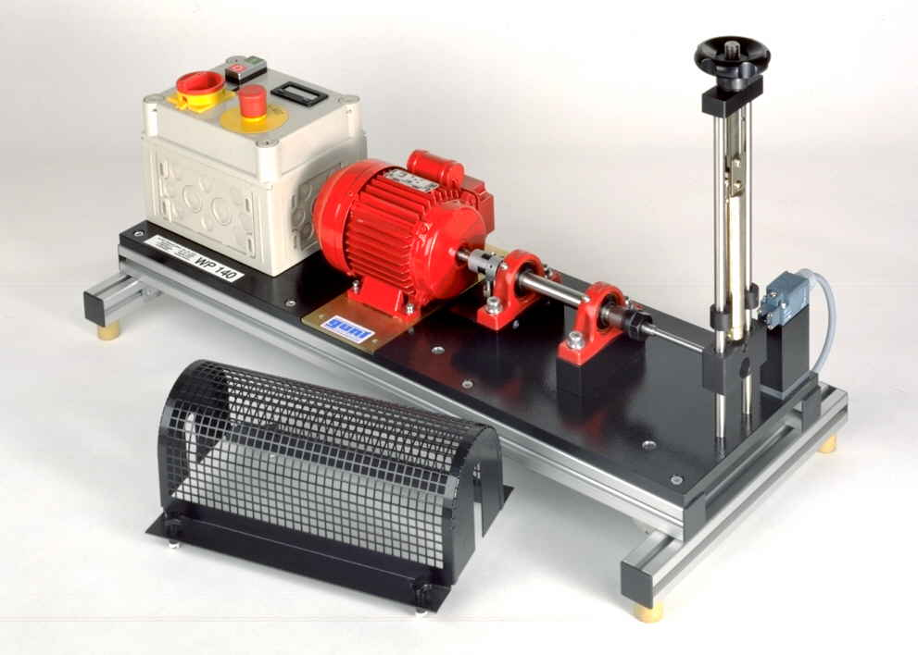
Figure 1 – fatigue test apparatus
Mild steel specimens

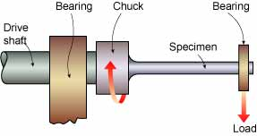
Figure2 - specimen
Theory :

1. From Latin "Fatigare" meaning "to tire."
2. Engineering terminology: - damage and failure of materials under cyclic loads.
3. Fatigue testing is defined as the process of progressive localized permanent structural change occurring in a material subjected to conditions that produce fluctuating stresses and strains at some point or points and that may culminate in cracks or complete fracture after a sufficient number of fluctuations.
Nomenclature to describe the test parameters involved in cyclic loading
Fatigue is the progressive, localized, permanent structural change that occurs in materials subjected to fluctuating stresses and strains that may result in cracks or fractures after a sufficient number of fluctuations. The cyclic stresses are normally well below the yield strength of the material.

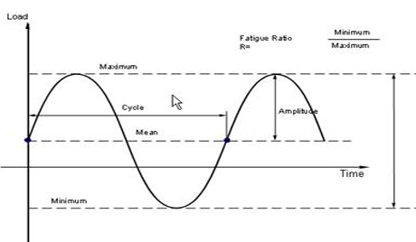
THE PROCESS OF FATIGUE CONSISTS OF THREE KEY STAGES:
1. Initial fatigue damage leading to crack nucleation and crack initiation,
2. Progressive cyclic growth of a crack (crack propagation) until the remaining un-cracked cross section of a part becomes too weak to withstand the loads applied,
3. Final, sudden fracture of the remaining cross section.
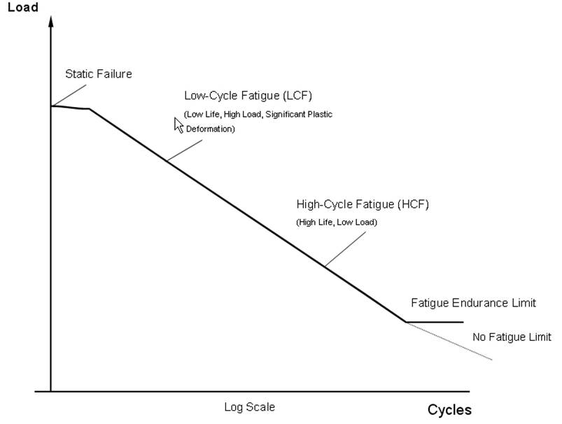

TYPES OF FATIGUE FAILURE:
1. Mechanical Fatigue - fluctuations in externally applied stresses or strains.
2. Creep Fatigue - Cyclic loads at high temperatures.
3. Thermo mechanical Fatigue - fluctuations in temperature as well as
stresses and strains.
4. Corrosion Fatigue - Cyclic loads in a chemically aggressive or embrittling
environment.
5. Fretting Fatigue - Cyclic loads combined with frictional sliding.
Fatigue Endurance Limit and Fatigue Strength

Cyclic loading generally produces failure however low the stress may be. However, with some materials the S-N curve levels off, suggesting that for these materials a limit of stress (load) can be specified - known as the fatigue limit - below which infinite life can be expected.
The fatigue life is thought to be associated with the phenomenon of strain ageing.
Most non ferrous alloys do not show a fatigue limit. Instead their S-N curves continue to drop at a slow rate (dotted line).
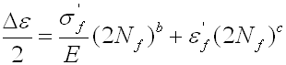
For these types of materials, the fatigue strength is quoted. This is the value of stress to which the material can be subjected to for a given number of cycles (10,000,000 cycles is the value often used).
Strain-Life Approach
Low cycle, high stress fatigue with appreciable plastic deformation. Uses the cyclic strain range versus number of
cycles to failure.
Total life = crack initiation + crack propagation (90% of
life can be crack initiation).
Failure = Typically a crack of predefined size.
The strain-life relationship is as follows:

WHERE THE CONSTANTS IN THE EQUATION ARE:
sf’ is the fatigue strength coefficient
E is the elastic modulus (Young's Modulus)
b is the fatigue strength exponent (Basquin’s exponent)
ef’ the fatigue ductility coefficient and c is the fatigue ductility exponent (the Coffin-Manson exponent)

STRESS-LIFE APPROACH
High cycle, low stress fatigue.
Material deforms elastically.
Cyclic stress range vs number of cycles to failure (S-N Curve)
Total life = crack initiation + crack propagation
Failure = Total separation of specimen
First fatigue design method. Large amount of data available.
Damage-Tolerant Approach
Assumes defects present in material.
Linear Elastic Fracture Mechanics approach ( da/dN vs delta K)
Resistance to Fatigue Crack Growth.
Useful Fatigue life = number of cycles to propagate a crack from an initial size to some critical dimension.

Collected data :
Table 1 – readings
specimen No. | load P | d | number of cycles
1 | 195 | 0.00787 | 16543
2 | 200 | 0.00783 | 15215
3 | 220 | 0.00783 | 11072
4 | 240 | 0.00778 | 3714

Calculated data and results :
Table2- results
specimen No. | load P | d | number of cycles | sress(MPA) | fatigue strength | R
1 | 195 | 0.00787 | 16543 | 448.2455778 | 896.4911556 | 0.786396
2 | 200 | 0.00783 | 15215 | 466.8209186 | 933.6418373 | 0.811862
3 | 220 | 0.00783 | 11072 | 513.5030105 | 1027.006021 | 0.893049
4 | 240 | 0.00778 | 3714 | 571.0551469 | 1142.110294 | 0.993139

Sample of calculations :
Specimen no1 :
P=195 , d=7.87mm , L=110mm
I = $\frac{πd^{4}}{64}= π*\frac{{0.00787}^{4}}{64}=1.78*{10}^{-10}$
$$M=F*d=195*0.110=21.45 N.m$$
$σ=M*\frac{y}{I}=\frac{21.45*\frac{0.00787}{2}}{1.78*{10}^{-10}}$ = 448.25 MPa

Plotted data :
Ultimate strength
Endurance limit

Figure 1 : S-N curve

Figure 2 : log(S)-log(N) curve

Besed on figure 1 : S(ult) = 1140 MPa
Endurance limit : 900 MPa
Discussion and conclusion :
From the results you can notice that :
- As the load applied increases fatigue strength increases while the number if cycles passed until fatigue happens decrease .
- Stress ratio increases as load increases
- Number of cycles is HIGHLY affected by the change in load , notice how it is reduced to almost 25% when the load in increased by 120%

Using endurance limit in machine design :
*For components made of ductile materials and those subjected to fluctuating forces , endurance limit is considered to be the criterion of failure . such components fail on account of fatigue . fatigue failure depends upon the amplitude of fluctuating stresses and the number of stress cycles, a number of factors affect endurance limit such as stress concentration , notch sensitivity , surface finish and even the size of component . fatigue failure is sudden and total and to account for dangerous aspects, the recommended factor of safety based on endurance limit is usually 1.3 to 1.5 .

*Also, the design of certain components such as cam and follower , gears , rolling contact bearings or rail and wheel is based on calculation of contact stresses by Hertz theory . failure of such components is usually in the form of small pits on the surface of the component . pitting is surface fatigue failure , which occurs when contact stress exceeds the surface endurance limit . the damage surface endurance limit can be improved by increasing the surface hardness .
The recommended factor of safety for such components is 1.8 to 2.5 based on endurance limit .

Sources of error :
*Errors while measuring the specimens dimentions
*Errors in the machine, like vibrations.
*The load doesn’t act on the body’s axis precisely.
*Imperfect surface finishing.
*Not taking the number of load cycles directly when the specimen is ruptured

To improve the test :
-choose a specimen with better surface finish and well measured dimentions
-be quick and exact when you take the reading of number of cycles
-the specimen should be attached properly to the machine .

