
University of jordan
School of engineering
Mechanical department

Strength Lab Report
Experiment #5
Hardness Test

Introduction
Hardness is the property of a material that enables it to resist elastic deformation , penetration , indentation and scratching therefore hardness is important from an engineering point of view because resistance to wear by either friction or erosion by steam , oil and water is increased with hardness , many hardness tests are available including Brinell and Rockwell which are based on indentation of the material and in this experiment three different materials are tested under these two tests .

Objectives
To perform a Rockwell test on three different metals (Steel , Brass and Aluminum for this experiment) using the correct indenter minor and major loads and scale to determine the Rockwell number for these metals , also to perform Brinell test on the same metals above , take readings using Brinell Microscope and to calculate the hardness number.

Apparatus

Rockwell hardness test machine Brinell microscope

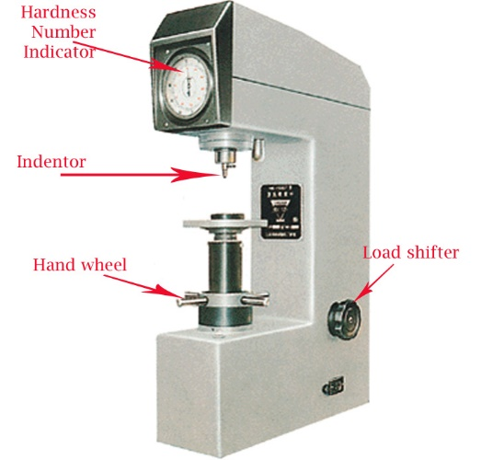
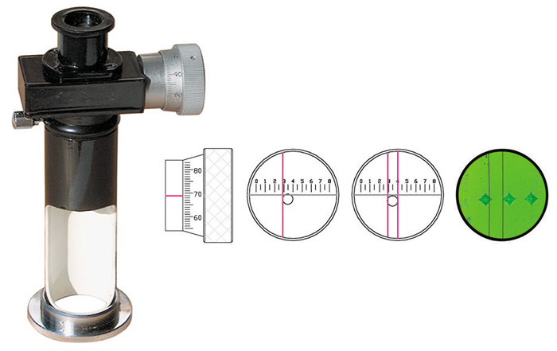

Brinell hardness test machine Metal Specimens
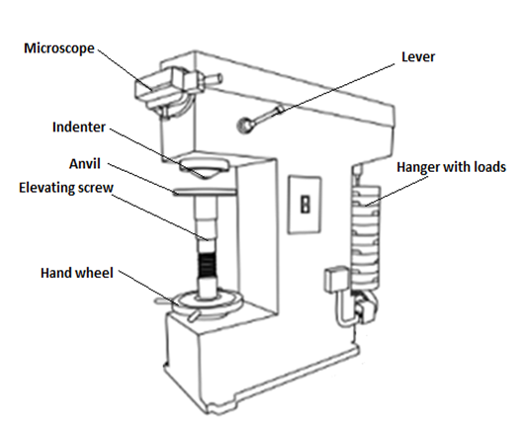
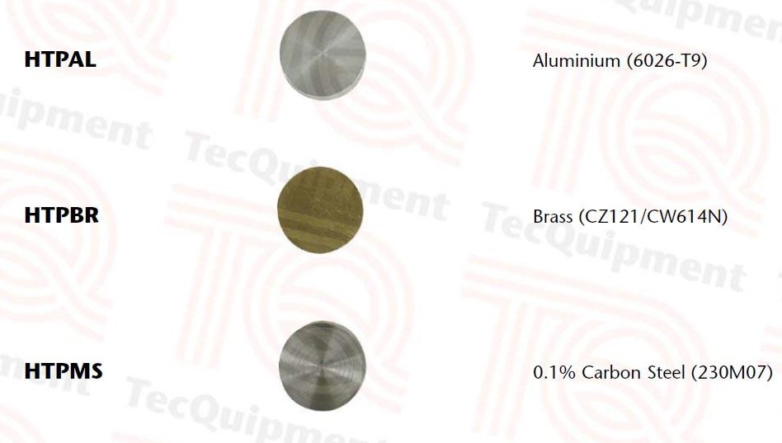

Theory
Hardness is not a fundamental property of a material. There are hardness ranges, however, within which certain materials lie. Hardness can be changed by heat, i.e. a workpiece takes on a different (higher) hardness value after heat treatment.
There are no set defined values for hardness. The hardness value determined during a hardness test can depend on:
- the choice of test method
- the test force applied to the indenter
- the length of time that the indenter remains in the material
- the indenter geometry
- the workpiece geometry

A principle distinction between the hardness testing methods generally used in technical testing is made between methods with static force application and those with dynamic force application.
In the static methods that are predominantly used for the hardness testing of metals, the test force is gradually increased (see illustration below), i.e. it is applied smoothly within a minimum time stipulated in the standards.
In the dynamic methods, on the other hand, the test force is applied abruptly so that the test specimen is subjected to an impact load.
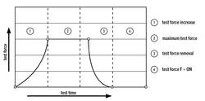

Methods with static application of the test force are predominantly used for testing the hardness of metals, whereby either the penetration depth or the size of the indentation caused by an indenter is measured. A distinction is made with the static hardness testing methods between depth measurement methods and optical measurement methods.
Depth measurement methods measure the residual depth of indentation left by the indenter. The Rockwell method is the only standardised depth measurement method (see ISO 6508, ASTM E18). There are also other, non-standardised depth measurement methods: Brinell and Vickers in the depth (HBT, HVT).
Optical measurement methods measure the residual size of indentation left by the indenter. Standardised optical hardness testing methods are Brinell (ISO 6506, ASTM E10), Knoop (ISO 4545, ASTM E384) and Vickers (ISO 6507, ASTM E384).
Alternatively, methods involving dynamic force application, such as the Leeb rebound method, in which the height of a ball rebound is measured, can also be used for hardness testing.

Collected data :
For Brinell test :
D (indenter) = 10mm

Material | Force exerted | Diameter
Steel | 3000 kgf | 4.5mm
brass | 750kgf | 3mm
Aluminum | 500 kgf | 2.5mm

for Rockwell test :
Material | Rh1 | Rh2 | Rh3 | Rh avg
Steel | 90.9 | 93 | 94.4 | 98.76
Brass | 73.3 | 73.2 | 72 | 72.83
Aluminum | 54.4 | 58.2 | 55.6 | 56.06

calculated data :
Material | Force exerted | Diameter | HB
Steel | 3000 kgf | 4.5mm | 178.539
brass | 750kgf | 3mm | 103.659
Aluminum | 500 kgf | 2.5mm | 100.241

Sample of calculations :
To calculate Brinell hardness number For steel :
$$HB=\frac{2*F \left(kgf\right)}{π*D\left(D-\sqrt{\left(D^{2}-d^{2}\right)}\right)\left(mm\right)}$$
$$=\frac{2*3000}{π*10(10-{\left(10^{2}-4.5^{2}\right)}^{0.5}}=178.539$$

Discussion :
Comparison between Brinelll and Rockwell

Rockwell | Brinell
No specimen preparation required | The specimen surface can be rough
Hardness value directly readable, no optical evaluation required | Good illumination of the test indent is important for ensuring correct evaluation of the test indent (e.g. with the aid of a ring light).
Quick & cost-effective process | The process is slow (by comparison with the Rockwell method). The test cycle takes somewhere between 30 and 60 seconds
Non-destructive testing | Limitation in applying the method on thin specimens of very hard materials
Not always the most accurate hardness testing method | High risk of deforming the material to be tested when testing in the macro range with high test loads
The test location must be completely free of all contamination (e.g. scale, foreign bodies or oil) | The surface quality of the specimen must be good, because the indent is measured optically
The indenter has unknown effects on the test results | Relatively large test indents that are easier to measure the rather small Vickers indentations
With increasing hardness, it becomes increasingly difficult to distinguish between materials | Can be used for testing non-homogeneous materials (e.g. castings)

The Rockwell method measures the permanent depth of indentation produced by a force/load on an indenter. First, a preliminary test force (commonly referred to as preload or minor load) is applied to a sample using a diamond or ball indenter. This preload breaks through the surface to reduce the effects of surface finish. After holding the preliminary test force for a specified dwell time, the baseline depth of indentation is measured.

Possible error sources:
- human errors: while measuring the diameters of the indentations
- error in devices like the Brinell microscope that we used to measure the diameters
- having other indentations close to the one we used in the analysis
- non-accurate values of the forces applied .

conclusion:
Rockwell hardness test is better than Brinell’s and other types of tests since it easier and more accurate, it also avoids the effects of surface finish.

Steel showed the highest value of hardness number in both tests

Rockwell hardness test avoids some human error because readings are taken from the machine itself which is more accurate.

