
University of jordan
School of engineering
Mechanical department

Strength Lab Report
Experiment #7
Impact Test

Introduction
The purpose of impact testing is to measure an object's ability to resist high-rate loading. It is usually thought of in terms of two objects striking each other at high relative speeds. A part, or material's ability to resist impact often is one of the determining factors in the service life of a part, or in the suitability of a designated material for a particular application. Impact resistance can be one of the most difficult properties to quantify. The ability to quantify this property is a great advantage in product liability and safety.
Impact energy is a measure of the work done to fracture a test specimen. When the striker impacts the specimen, the specimen will absorb energy until it yields. ... The test specimen continues to absorb energy and work hardens at the plastic zone at the notch. When the specimen can absorb no more energy, fracture occurs.

Objective :
To determine the energy absorbed by several specimens of different materials and notches during fracture and use it as a measure of the specimen’s toughness.

Procedure :

1) The dimensions of the unnotched length and the thickness of the specimen are measured.
2) The pendulum is raised to the left until it indicates the maximum energy range on the upperindicator unit.
3) The specimen is placed horizontally across supports with the notch away from the pendulum
4) Pendulum is released.
5) The indicated value from the indicator unit is recorded.
6) The brake is applied until the pendulum has returned to its stable hanging vertical position.
7) The specimen is removed from the testing area and failure

Theory :

Impact test is a test used in studying the toughness of material. The definition oftoughness is defined as the capacity of material to absorb energy and deform plasticallybefore fracturing. Toughness is associated with both ductility and strength of materials.
Since the amount of plastic deformation that occurs before fracture is a measure of theductility of the material and because the stress needed to cause fracture isa measure ofits strength, it follows that toughness is associated with both the ductility and strength ofthe material.
Impact test involves the sudden and dynamic application of the load. For thispurpose, in general, a pendulum is made to swing from a fixed height and strike thestandard impact specimen. There are two types of method to test impact test which is Izodtest and Charpy test. These two methods are different in placing the specimens. In Izodtest, the specimen is placed in vertical position and the notch area is facing the pendulum.Meanwhile in Charpy test, the specimen is placed horizontally with unnotched area facingthe pendulum. Moreover, Izod impact specimen only has a V-notch specimen whileCharpy impact specimen has both U-notch and V-notch specimen. Charpy test result canindicate how brittle the materials are. The most common method for the measurement ofimpact strength that is Charpy tests is used in this experiment.

Data observed :

Table 1
test | meterial | Cross section | notch | Impact value
izod | Steel  Steel  Brass  Brass | 10*10  10*10  10*10  10*10 | V  U  V  U | 124  50  20  29
charpy | Steel  Steel  Brass  Brass | 10*10  10*10  10*10  10*10 | V  U  V  U | 70  98  70  95

Sample calculations :
Izod :Energy losses=4 joule
For steel v :
Impact value=124-4=120

Table 2
test | meterial | Cross section | notch | Impact value
izod | Steel  Steel  Brass  Brass | 10*10  10*10  10*10  10*10 | V  U  V  U | 120  46  16  25

Results :

Izod:
1)The beam held in vertical position.
2) The impact is on the plane of notch.
3)The notch is facing the striker.
Charpy:
1)The beam held horizontal position.
2)The impact is on the backside of the notch.
3)The notch is opposing the striker.

Apparatus :
Machines :
Izod testing machine : Charpy testing machine
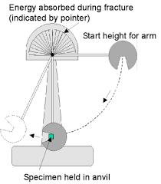
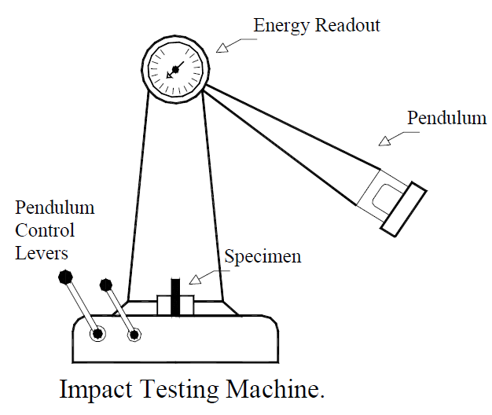
Figure 1
Figure 2

Specimens used :
Steel and brass
V-notch U-notch
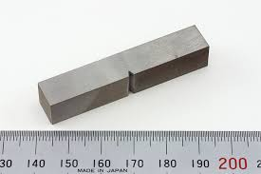
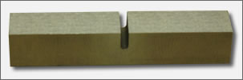
Figure 3 Figure 4

Comparison between Izod test and Charpy test :

 | Izod test | Charpy test
Position of specimen | the test material was placed in a vertical position | the test material was placed horizontally
Position of notch | facing the striker | away from the striker
Hammer type | Farming hammer | Ball Pin hammer
Striker position | striker swings downward, hitting the test material in the middle, at the bottom of its swing, and is Left free at top  (edge of the anvil is at the same level of the lower edge of the notch) | the striker hits the center of the test material, behind a machined notch. The notch is positioned away from the striker, fastened in a pendulum
Purpose of the test | used to evaluate the materials for overall hardiness. It’s not applicable to compound materials because of the influence of complicated and inconsistent failure modes. | higher speeds and collision energy could be achieved in a Vertical style fall .This method proved to be reliable, and gave qualitative collision data.
( Table 3)
**both tests are used to find the absorbed energy
**both tests uses swinging pendulums
**the specimens used in both tests contain notches.

Discussion :
Notches are important in this test to cause test concentration, as a result brittle fracture will occur instead of deformation of the specimen (decreases ductile failure)
V notch causes more stress concentration which means it is easier for a specimen with a V notch to reach fracture than a U notch, the results of the test also shows that this is true because as you can see energy absorbed by the U notch brass specimen was 25 Joules it was 16 Joules for the V notch and the same result is repeated for other specimens using both tests izod and charpy.
Impact test is important to have a measure of a given material's toughness and acts as a tool to study temperature-dependent brittle-ductile transition.
It is to determine whether the material is brittle or ductile in nature.
Energy loss due to friction was subtracted from the readings to get the final absorbed energy.
If the pendulum keeps going back and forth after the fracture of the specimen test has to be repeated.
Fracture occurred as the following figure :
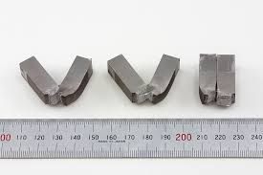
Figure 5
Possible sources of error :
- Error in the specimen itself : being non-homogeneous or errors in the position or the shape and dimentions of the notches .
- Human errors : taking false readings , taking a long time to stop the pendulum after fracture , taking wrong dimentions.
- Machine error : the pendulum is not stopped exactly after fracture because it should be stopped by us , friction .
- Force is not acted directly on the axis of the specimen (charpy test)
To reduce the error :
Be extra careful and exact when taking any readings
Try to stop the pendulum right after the fracture
Repeat the test more than once to get more accurate results and compare the
Conclusion :
Steel showed higher values of energy absorbed in both tests which means steel has higher toughness than Brass.
The izod and charpy tests gave different values of energy absorbed by the same specimen due to the difference in the hammers and the position of the specimens but they both gave the same result (that steel is Taugher than Brass and U notch causes less stress concentration)

