
University of jordan
School of engineering
Mechanical department

Strength Lab Report
Experiment #8
Strain gauge

Introduction
A strain gage (sometimes referred to as a Strain gauge) is a sensor whose resistance varies with applied force; It converts force, pressure, tension, weight, etc., into a change in electrical resistance which can then be measured. When external forces are applied to a stationary object, stress and strain are the result. Stress is defined as the object's internal resisting forces, and strain is defined as the displacement and deformation that occur.
The strain gage is one of the most important sensor of the electrical measurement technique applied to the measurement of mechanical quantities. As their name indicates, they are used for the measurement of strain. As a technical term "strain" consists of tensile and compressive strain, distinguished by a positive or negative sign. Thus, strain gages can be used to pick up expansion as well as contraction.

Objective :
To compare the experimental results of stress and strain resulting from the strain gauge experiment with theoretical results.

Apparatus
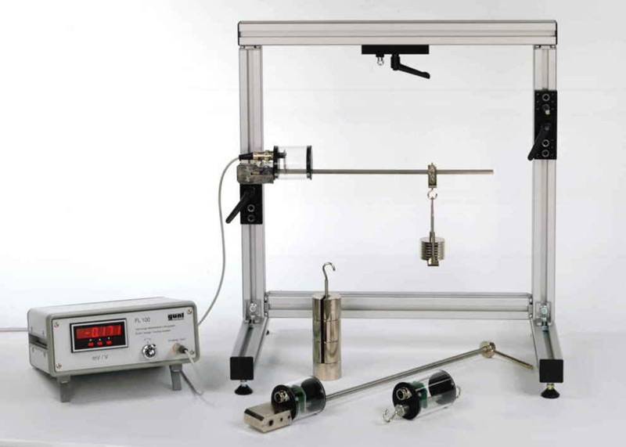

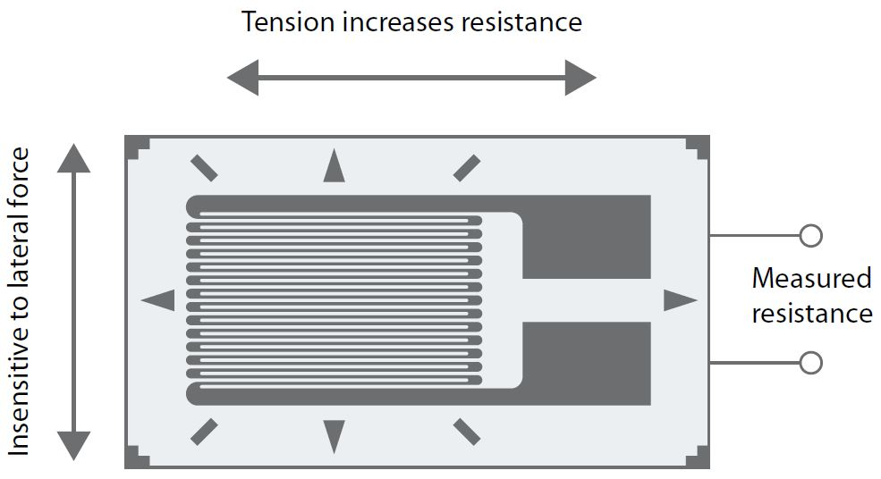
Theory :
The strain gage is one of the most widely used strain measurement sensors. It is a resistive elastic unit whose change in resistance is a function of applied strain.
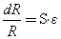
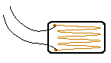
where R is the resistance, ε is the strain, and S is the strain sensitivity factor of the gage material (gage factor in some books).
Among strain gages, an electric resistance wire strain gage has the advantages of lower cost and being an established product. Thus it is the most commonly used type of device. Other types of strain gages are acoustic, capacitive, inductive, mechanical, optical, piezo-resistive, and semi-conductive.
A wire strain gage is made by a resistor, usually in metal foil form, bonded on an elastic backing. Its principle is based on fact that the resistance of a wire increases with increasing strain and decreases with decreasing strain, as first reported by Lord Kelvin in 1856.
Consider a wire strain gage, as illustrated above. The wire is composed of a uniform conductor of electric resistivity ρ with length l and cross-section area A. Its resistance R is a function of the geometry given by
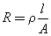
The resistance change rate is a combination effect of changes in length, cross-section area, and resistivity.
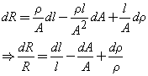
When the strain gage is attached and bonded well to the surface of an object, the two are considered to deform together. The strain of the strain gage wire along the longitudinal direction is the same as the strain on the surface in the same direction.
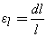
However, its cross-sectional area will also change due to the Poisson's ratio. Suppose that the wire is cylindrical with initial radius r. The normal strain along the radial direction is
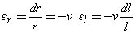
The change rate of cross-section area is twice as the radial strain, when the strain is small.
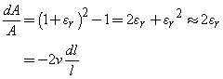
The resistance change rate becomes
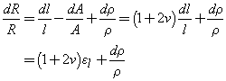
For a given material, the sensitivity of resistance versus strain can be calibrated by the following equation.
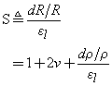
When the sensitivity factor S is given, (usually provided by strain gage vendors) the average strain at the point of attachment of the strain gage can be obtained by measuring the change in electric resistance of the strain gage.
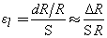

Collected data :
Table 1
 |  | Bending | Experiment
Load in N | 0 | 1 | 2 | 3 | 4.5 | 5.5
Reading in Mv/V | 0 | 0.035 | 0.71 | 0.105 | 0.157 | 0.192

Table 2
 |  | Tensile | Experiment
Load in N | 0 | 10 | 20 | 30 | 40
Reading in Mv/V | 0 | 0.005 | 0.008 | 0.012 | 0.015

Table3
 |  | Torsion | Experiment
Load in N | 0 | 5 | 10 | 15 | 20
Reading in Mv/V | 0 | 0.035 | 0.07 | 0.104 | 0.139

Calculated data :
Bending experiment :
Table 4
Load in N | 0 | 1 | 2 | 3 | 4.5 | 5.5
Reading in mV/V | 0 | 0.035 | 0.071 | 0.105 | 0.157 | 0.192
exp strain (mm) | 0 | 0.0170732 | 0.034634 | 0.05122 | 0.076585 | 0.093659
exp stress (Mpa) | 0 | 3.5853659 | 7.273171 | 10.7561 | 16.08293 | 19.66829
theo stress (Mpa) | 0 | 3.3661769 | 6.732354 | 10.09853 | 15.1478 | 18.51397
theo strain (mm) | 0 | 0.0160294 | 0.032059 | 0.048088 | 0.072132 | 0.088162
error % |  | 6.5115091 | 8.033102 | 6.511509 | 6.173377 | 6.234856

Torsion experiment :
Table 5
 |  | Torsion | Experiment
Load in N | 0 | 5 | 10 | 15 | 20
Reading in mV/V | 0 | 0.035 | 0.07 | 0.104 | 0.139
exp strain (mm) | 0 | 0.017073 | 0.034146 | 0.050732 | 0.067805
exp stress (Mpa) | 0 | 2.731707 | 5.463415 | 8.117073 | 10.84878
theo stress (Mpa) | 0 | 2.547771 | 5.095541 | 7.643312 | 10.19108
theo strain (mm) | 0 | 0.015924 | 0.031847 | 0.047771 | 0.063694
error % |  | 7.219512 | 7.219512 | 6.198374 | 6.453659

Tensile experiment :
Table 6
 |  | Tensile | Experiment
Load in N | 0 | 10 | 20 | 30 | 40
Reading in Mv/V | 0 | 0.005 | 0.008 | 0.012 | 0.015
exp strain (mm) | 0 | 0.0071376 | 0.005981 | 0.008971 | 0.011214
exp stress (Kpa) | 0 | 713.952 | 1142.323 | 1713.485 | 2141.856
theo stress (Kpa) | 0 | 500 | 1000 | 1500 | 2000
theo strain (mm) | 0 | 0.002618 | 0.005236 | 0.007853 | 0.010471
error % |  | 19.611 | 14.23231 | 14.23231 | 7.092795

Sample calculations :
Bending experiment :
For load = 10N
$ɛ \left(ex\right)=\frac{1}{k}*\frac{V}{V}=\frac{1}{2.05}*0.005=0.01707$
$σ \left(ex\right)=E*ɛ=210000*0.01707*10^3=3.58536MPa$
$$σ\left(theoretical\right)=\frac{6*F*L}{bh^{2}}=\frac{6*10*0.25}{{0.00475}^{2}*0.01975}=3.366MPa$$
$$ɛ \left(theoretical\right)=\frac{σ}{E}=\frac{3.366}{210000}=0.01602$$

torsion experiment :
for load=5 N
$ɛ \left(ex\right)=\frac{1}{k}*\frac{V}{V}=\frac{1}{2.05}*0.035=0.01707$
$τ \left(ex\right)=G*2ɛ=80000*2*0.01707*10^3=2.731200MPa$
$$τ\left(theoretical\right)=\frac{16*T}{π*d^{3}}=\frac{6*5*0.1}{3.14*{0.01}^{2}}=2.5477 MPa$$
$$ɛ \left(theoretical\right)=\frac{τ}{2G}=\frac{2.5477}{2*80000}=0.015923 mm$$

tensile experiment :
for load = 10 N µ=0.305 E=191000
$$ɛ \left(ex\right)=\frac{4}{2k}*\frac{1}{\left(1+µ\right)}*\frac{V}{V}=\frac{2}{2.05}*\frac{1}{\left(1+0.350\right)}*0.005=0.00361336$$
$$σ \left(ex\right)=E*ɛ=191000*0.00361 =3.58536MPa$$

Types of strain gauges :
1. Unbonded metal strain gauges
2. Bonded metal wire strain gauges
3. Bonded metal foil strain gauges
4. Vacuum deposited thin metal film strain gauges
5. Sputter deposited thin metal strain gauges
6. Bonded semiconductor strain gauges
7. Diffused metal strain gauges.

Conclusion:
For bending experiment :
The experimental results obtained were quite close to the theoritical results with an error range (6-6.5%)

For torsion experiment :
Experimental results were also quite close to the theoretical results with an error range of (6-7.5%)

For tension experiment :
Experimental results were also quite close to the theoretical results with an error range of (7-19.6%)

