Introduction
Tension test is run on material specimens to determine the material’s properties associated with its behavior against forces that are applied on it , which is important for the selection of the material type in design and choosing the right dimensions of components to be functional and useful .
The purpose of this experiment is to determine the mechanical properties of after applying the tension test on a specimen with known dimensions (gage length and diameter) , the specimen will be fitted in to the machine and the load will gradually increase until fracture occurs , tabulated data will be used to find all properties we want .

Apparatus
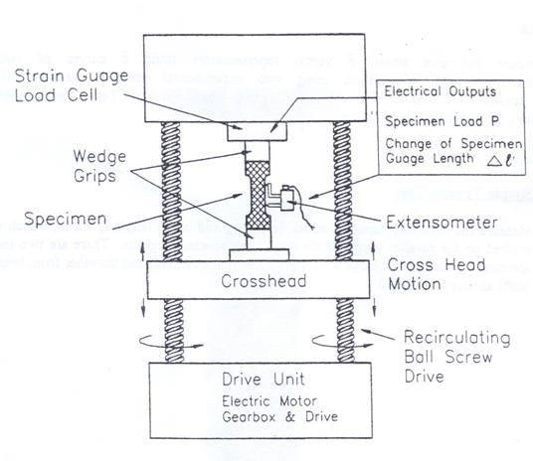
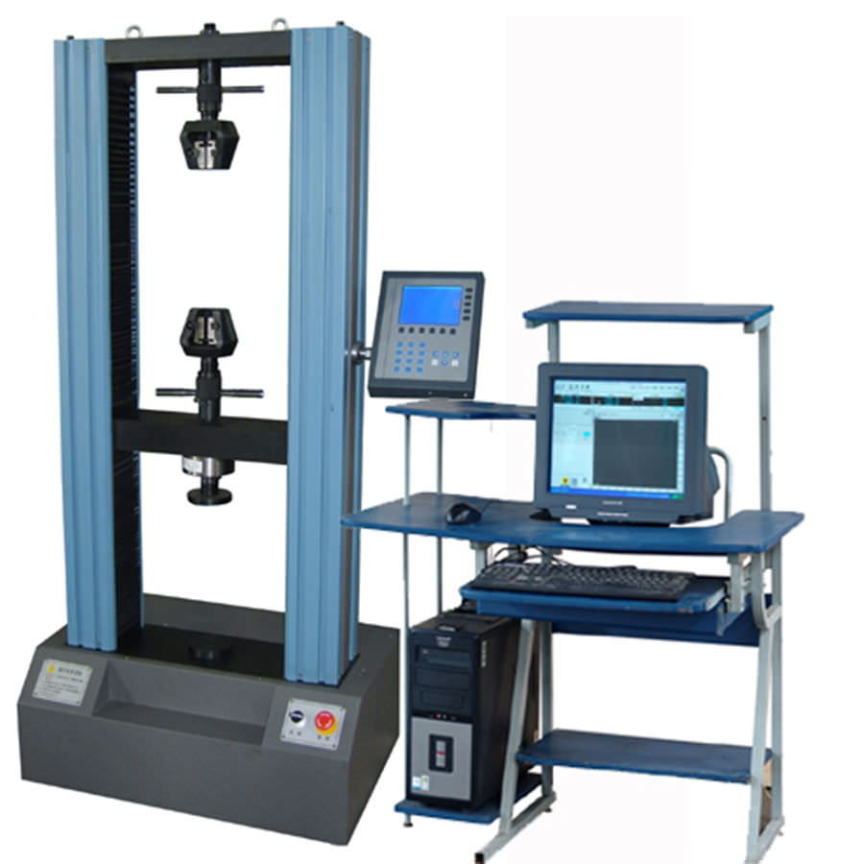

A tension test machine connected with a sensor and a computer that collects and tabulates the data to an excel sheet .

Specimen of low carbon steel with the following dimensions :
Gage length = 93.11 mm
Average diameter = 7.99 mm

Theory
A tensile load is applied to the specimen until it fractures. During the test,
the load required to make a certain elongation on the material is recorded. A loadelongation
curve is plotted by an x-y recorder, so that the tensile behavior of the
material can be obtained. An engineering stress-strain curve can be constructed
from this load-elongation curve by making the required calculations. Then the
mechanical parameters that we search for can be found by studying on this curve.
Gage length (L0) do
3
A typical engineering stress-strain diagram and the significant parameters
are shown on the figure in appendix.
Engineering Stress is obtained by dividing the load by the original area of the
cross section of the specimen.
Stress σ = P/Ao ( Load/Initial cross-sectional area)
Strain = e = ∆l/lo (Elongation/Initial gage length)
Engineering stress and strain are independent of the geometry of the
specimen.
Elastic Region: The part of the stress-strain curve up to the yielding point.
Elastic deformation is recoverable. In the elastic region, stress and strain are
related to each other linearly.
Hooke’s Law: σ = Ee
The linearity constant E is called the elastic modulus which is specific for
each type of material.
Plastic Region: The part of the stress-strain diagram after the yielding point.
At the yielding point, the plastic deformation starts. Plastic deformation is
permanent. At the maximum point of the stress-strain diagram (σUTS), necking
starts.

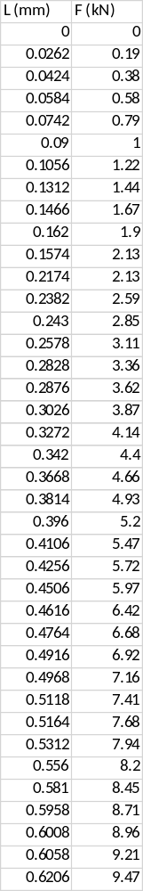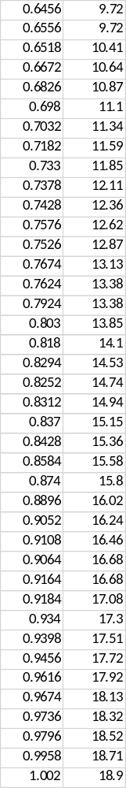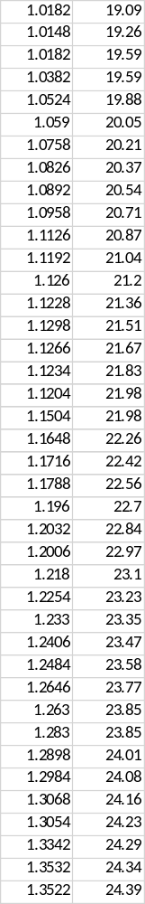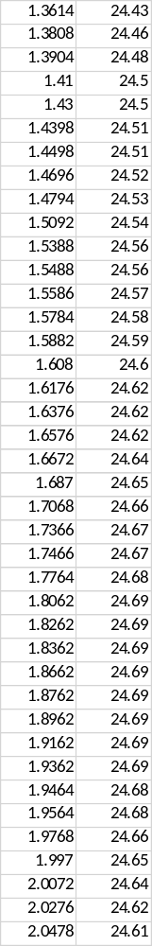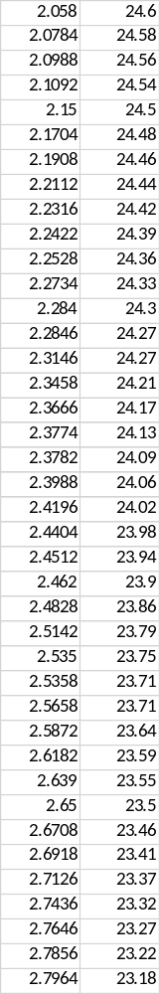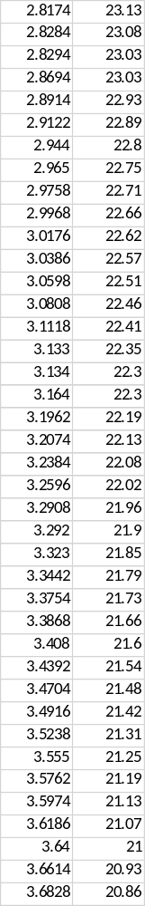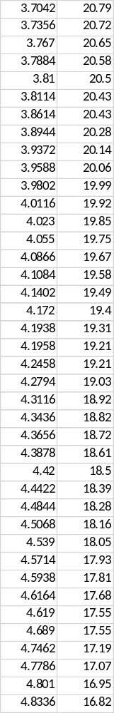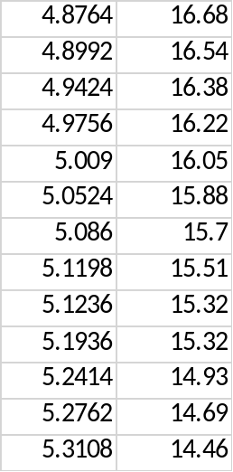

Reduced data
L (mm) | F (kN) | stress | strain | true stress | true strain
0 | 0 | 0 | 0 | 0 | 0
0.0262 | 0.19 | 0.003789 | 0.000281 | 0.00379 | 0.000281
0.0424 | 0.38 | 0.007579 | 0.000455 | 0.007582 | 0.000455
0.0584 | 0.58 | 0.011568 | 0.000627 | 0.011575 | 0.000627
0.0742 | 0.79 | 0.015756 | 0.000797 | 0.015768 | 0.000797
0.09 | 1 | 0.019944 | 0.000967 | 0.019963 | 0.000966
0.1056 | 1.22 | 0.024332 | 0.001134 | 0.02436 | 0.001133
0.1312 | 1.44 | 0.02872 | 0.001409 | 0.02876 | 0.001408
0.1466 | 1.67 | 0.033307 | 0.001574 | 0.033359 | 0.001573
0.162 | 1.9 | 0.037894 | 0.00174 | 0.03796 | 0.001738
0.1574 | 2.13 | 0.042481 | 0.00169 | 0.042553 | 0.001689
0.2174 | 2.13 | 0.042481 | 0.002335 | 0.04258 | 0.002332
0.2382 | 2.59 | 0.051655 | 0.002558 | 0.051788 | 0.002555
0.243 | 2.85 | 0.056841 | 0.00261 | 0.056989 | 0.002606
0.2578 | 3.11 | 0.062026 | 0.002769 | 0.062198 | 0.002765
0.2828 | 3.36 | 0.067013 | 0.003037 | 0.067216 | 0.003033
0.2876 | 3.62 | 0.072198 | 0.003089 | 0.072421 | 0.003084
0.3026 | 3.87 | 0.077184 | 0.00325 | 0.077435 | 0.003245
0.3272 | 4.14 | 0.082569 | 0.003514 | 0.082859 | 0.003508
0.342 | 4.4 | 0.087754 | 0.003673 | 0.088077 | 0.003666
0.3668 | 4.66 | 0.09294 | 0.003939 | 0.093306 | 0.003932
0.3814 | 4.93 | 0.098325 | 0.004096 | 0.098728 | 0.004088
0.396 | 5.2 | 0.10371 | 0.004253 | 0.104151 | 0.004244
0.4106 | 5.47 | 0.109095 | 0.00441 | 0.109576 | 0.0044
0.4256 | 5.72 | 0.114081 | 0.004571 | 0.114602 | 0.004561
0.4506 | 5.97 | 0.119067 | 0.004839 | 0.119643 | 0.004828
0.4616 | 6.42 | 0.128042 | 0.004958 | 0.128677 | 0.004945
0.4764 | 6.68 | 0.133227 | 0.005117 | 0.133909 | 0.005103
0.4916 | 6.92 | 0.138014 | 0.00528 | 0.138743 | 0.005266
0.4968 | 7.16 | 0.1428 | 0.005336 | 0.143562 | 0.005321
0.5118 | 7.41 | 0.147787 | 0.005497 | 0.148599 | 0.005482
0.5164 | 7.68 | 0.153171 | 0.005546 | 0.154021 | 0.005531
0.5312 | 7.94 | 0.158357 | 0.005705 | 0.15926 | 0.005689
0.556 | 8.2 | 0.163542 | 0.005971 | 0.164519 | 0.005954
0.581 | 8.45 | 0.168528 | 0.00624 | 0.16958 | 0.006221
0.5958 | 8.71 | 0.173714 | 0.006399 | 0.174826 | 0.006378
0.6008 | 8.96 | 0.1787 | 0.006453 | 0.179853 | 0.006432
0.6058 | 9.21 | 0.183686 | 0.006506 | 0.184881 | 0.006485
0.6206 | 9.47 | 0.188872 | 0.006665 | 0.19013 | 0.006643
0.6456 | 9.72 | 0.193858 | 0.006934 | 0.195202 | 0.00691
0.6556 | 9.72 | 0.193858 | 0.007041 | 0.195223 | 0.007016
0.6518 | 10.41 | 0.207619 | 0.007 | 0.209073 | 0.006976
0.6672 | 10.64 | 0.212206 | 0.007166 | 0.213727 | 0.00714
0.6826 | 10.87 | 0.216793 | 0.007331 | 0.218383 | 0.007304
0.698 | 11.1 | 0.221381 | 0.007497 | 0.22304 | 0.007469
0.7032 | 11.34 | 0.226167 | 0.007552 | 0.227875 | 0.007524
0.7182 | 11.59 | 0.231153 | 0.007713 | 0.232936 | 0.007684
0.733 | 11.85 | 0.236339 | 0.007872 | 0.238199 | 0.007842
0.7378 | 12.11 | 0.241524 | 0.007924 | 0.243438 | 0.007893
0.7428 | 12.36 | 0.24651 | 0.007978 | 0.248477 | 0.007946
0.7576 | 12.62 | 0.251696 | 0.008137 | 0.253744 | 0.008104
0.7526 | 12.87 | 0.256682 | 0.008083 | 0.258757 | 0.00805
0.7674 | 13.13 | 0.261867 | 0.008242 | 0.264026 | 0.008208
0.7624 | 13.38 | 0.266853 | 0.008188 | 0.269038 | 0.008155
0.7924 | 13.38 | 0.266853 | 0.00851 | 0.269124 | 0.008474
0.803 | 13.85 | 0.276227 | 0.008624 | 0.278609 | 0.008587
0.818 | 14.1 | 0.281213 | 0.008785 | 0.283684 | 0.008747
0.8294 | 14.53 | 0.289789 | 0.008908 | 0.292371 | 0.008868
0.8252 | 14.74 | 0.293978 | 0.008863 | 0.296583 | 0.008824
0.8312 | 14.94 | 0.297966 | 0.008927 | 0.300626 | 0.008887
0.837 | 15.15 | 0.302155 | 0.008989 | 0.304871 | 0.008949
0.8428 | 15.36 | 0.306343 | 0.009052 | 0.309116 | 0.009011
0.8584 | 15.58 | 0.310731 | 0.009219 | 0.313595 | 0.009177
0.874 | 15.8 | 0.315118 | 0.009387 | 0.318076 | 0.009343
0.8896 | 16.02 | 0.319506 | 0.009554 | 0.322559 | 0.009509
0.9052 | 16.24 | 0.323894 | 0.009722 | 0.327043 | 0.009675
0.9108 | 16.46 | 0.328282 | 0.009782 | 0.331493 | 0.009734
0.9064 | 16.68 | 0.332669 | 0.009735 | 0.335908 | 0.009688
0.9164 | 16.68 | 0.332669 | 0.009842 | 0.335943 | 0.009794
0.9184 | 17.08 | 0.340647 | 0.009864 | 0.344007 | 0.009815
0.934 | 17.3 | 0.345035 | 0.010031 | 0.348496 | 0.009981
0.9398 | 17.51 | 0.349223 | 0.010093 | 0.352748 | 0.010043
0.9456 | 17.72 | 0.353411 | 0.010156 | 0.357 | 0.010105
0.9616 | 17.92 | 0.3574 | 0.010328 | 0.361091 | 0.010275
0.9674 | 18.13 | 0.361588 | 0.01039 | 0.365345 | 0.010336
0.9736 | 18.32 | 0.365378 | 0.010456 | 0.369198 | 0.010402
0.9796 | 18.52 | 0.369367 | 0.010521 | 0.373253 | 0.010466
0.9958 | 18.71 | 0.373156 | 0.010695 | 0.377147 | 0.010638
1.002 | 18.9 | 0.376945 | 0.010761 | 0.381002 | 0.010704
1.0182 | 19.09 | 0.380735 | 0.010935 | 0.384898 | 0.010876
1.0148 | 19.26 | 0.384125 | 0.010899 | 0.388312 | 0.01084
1.0182 | 19.59 | 0.390707 | 0.010935 | 0.394979 | 0.010876
1.0382 | 19.59 | 0.390707 | 0.01115 | 0.395063 | 0.011089
1.0524 | 19.88 | 0.396491 | 0.011303 | 0.400972 | 0.011239
1.059 | 20.05 | 0.399881 | 0.011374 | 0.404429 | 0.011309
1.0758 | 20.21 | 0.403072 | 0.011554 | 0.407729 | 0.011488
1.0826 | 20.37 | 0.406263 | 0.011627 | 0.410987 | 0.01156
1.0892 | 20.54 | 0.409654 | 0.011698 | 0.414446 | 0.01163
1.0958 | 20.71 | 0.413044 | 0.011769 | 0.417905 | 0.0117
1.1126 | 20.87 | 0.416235 | 0.011949 | 0.421209 | 0.011878
1.1192 | 21.04 | 0.419626 | 0.01202 | 0.42467 | 0.011949
1.126 | 21.2 | 0.422817 | 0.012093 | 0.42793 | 0.012021
1.1228 | 21.36 | 0.426008 | 0.012059 | 0.431145 | 0.011987
1.1298 | 21.51 | 0.429 | 0.012134 | 0.434205 | 0.012061
1.1266 | 21.67 | 0.432191 | 0.0121 | 0.43742 | 0.012027
1.1234 | 21.83 | 0.435382 | 0.012065 | 0.440635 | 0.011993
1.1204 | 21.98 | 0.438374 | 0.012033 | 0.443649 | 0.011961
1.1504 | 21.98 | 0.438374 | 0.012355 | 0.44379 | 0.01228
1.1648 | 22.26 | 0.443958 | 0.01251 | 0.449512 | 0.012432
1.1716 | 22.42 | 0.447149 | 0.012583 | 0.452775 | 0.012504
1.1788 | 22.56 | 0.449941 | 0.01266 | 0.455638 | 0.012581
1.196 | 22.7 | 0.452733 | 0.012845 | 0.458549 | 0.012763
1.2032 | 22.84 | 0.455526 | 0.012922 | 0.461412 | 0.01284
1.2006 | 22.97 | 0.458118 | 0.012894 | 0.464025 | 0.012812
1.218 | 23.1 | 0.460711 | 0.013081 | 0.466738 | 0.012996
1.2254 | 23.23 | 0.463304 | 0.013161 | 0.469401 | 0.013075
1.233 | 23.35 | 0.465697 | 0.013242 | 0.471864 | 0.013155
1.2406 | 23.47 | 0.46809 | 0.013324 | 0.474327 | 0.013236
1.2484 | 23.58 | 0.470284 | 0.013408 | 0.47659 | 0.013319
1.2646 | 23.77 | 0.474074 | 0.013582 | 0.480512 | 0.01349
1.263 | 23.85 | 0.475669 | 0.013565 | 0.482121 | 0.013473
1.283 | 23.85 | 0.475669 | 0.013779 | 0.482224 | 0.013685
1.2898 | 24.01 | 0.47886 | 0.013852 | 0.485494 | 0.013757
1.2984 | 24.08 | 0.480256 | 0.013945 | 0.486953 | 0.013848
1.3068 | 24.16 | 0.481852 | 0.014035 | 0.488615 | 0.013937
1.3054 | 24.23 | 0.483248 | 0.01402 | 0.490023 | 0.013923
1.3342 | 24.29 | 0.484445 | 0.014329 | 0.491386 | 0.014228
1.3532 | 24.34 | 0.485442 | 0.014533 | 0.492497 | 0.014429
1.3522 | 24.39 | 0.486439 | 0.014523 | 0.493503 | 0.014418
1.3614 | 24.43 | 0.487237 | 0.014621 | 0.494361 | 0.014516
1.3808 | 24.46 | 0.487835 | 0.01483 | 0.49507 | 0.014721
1.3904 | 24.48 | 0.488234 | 0.014933 | 0.495525 | 0.014822
1.41 | 24.5 | 0.488633 | 0.015143 | 0.496032 | 0.01503
1.43 | 24.5 | 0.488633 | 0.015358 | 0.496137 | 0.015241
1.4398 | 24.51 | 0.488832 | 0.015463 | 0.496391 | 0.015345
1.4498 | 24.51 | 0.488832 | 0.015571 | 0.496444 | 0.015451
1.4696 | 24.52 | 0.489032 | 0.015783 | 0.49675 | 0.01566
1.4794 | 24.53 | 0.489231 | 0.015889 | 0.497004 | 0.015764
1.5092 | 24.54 | 0.489431 | 0.016209 | 0.497364 | 0.016079
1.5388 | 24.56 | 0.48983 | 0.016527 | 0.497925 | 0.016392
1.5488 | 24.56 | 0.48983 | 0.016634 | 0.497977 | 0.016497
1.5586 | 24.57 | 0.490029 | 0.016739 | 0.498232 | 0.016601
1.5784 | 24.58 | 0.490228 | 0.016952 | 0.498539 | 0.01681
1.5882 | 24.59 | 0.490428 | 0.017057 | 0.498793 | 0.016913
1.608 | 24.6 | 0.490627 | 0.01727 | 0.4991 | 0.017122
1.6176 | 24.62 | 0.491026 | 0.017373 | 0.499557 | 0.017224
1.6376 | 24.62 | 0.491026 | 0.017588 | 0.499662 | 0.017435
1.6576 | 24.62 | 0.491026 | 0.017803 | 0.499768 | 0.017646
1.6672 | 24.64 | 0.491425 | 0.017906 | 0.500224 | 0.017747
1.687 | 24.65 | 0.491625 | 0.018118 | 0.500532 | 0.017956
1.7068 | 24.66 | 0.491824 | 0.018331 | 0.50084 | 0.018165
1.7366 | 24.67 | 0.492023 | 0.018651 | 0.5012 | 0.018479
1.7466 | 24.67 | 0.492023 | 0.018758 | 0.501253 | 0.018585
1.7764 | 24.68 | 0.492223 | 0.019079 | 0.501614 | 0.018899
1.8062 | 24.69 | 0.492422 | 0.019399 | 0.501975 | 0.019213
1.8262 | 24.69 | 0.492422 | 0.019613 | 0.50208 | 0.019423
1.8362 | 24.69 | 0.492422 | 0.019721 | 0.502133 | 0.019529
1.8662 | 24.69 | 0.492422 | 0.020043 | 0.502292 | 0.019845
1.8762 | 24.69 | 0.492422 | 0.02015 | 0.502345 | 0.01995
1.8962 | 24.69 | 0.492422 | 0.020365 | 0.502451 | 0.020161
1.9162 | 24.69 | 0.492422 | 0.02058 | 0.502556 | 0.020371
1.9362 | 24.69 | 0.492422 | 0.020795 | 0.502662 | 0.020581
1.9464 | 24.68 | 0.492223 | 0.020904 | 0.502512 | 0.020689
1.9564 | 24.68 | 0.492223 | 0.021012 | 0.502565 | 0.020794
1.9768 | 24.66 | 0.491824 | 0.021231 | 0.502266 | 0.021009
1.997 | 24.65 | 0.491625 | 0.021448 | 0.502169 | 0.021221
2.0072 | 24.64 | 0.491425 | 0.021557 | 0.502019 | 0.021328
2.0276 | 24.62 | 0.491026 | 0.021776 | 0.501719 | 0.021543
2.0478 | 24.61 | 0.490827 | 0.021993 | 0.501622 | 0.021755
2.058 | 24.6 | 0.490627 | 0.022103 | 0.501472 | 0.021862
2.0784 | 24.58 | 0.490228 | 0.022322 | 0.501171 | 0.022076
2.0988 | 24.56 | 0.48983 | 0.022541 | 0.500871 | 0.022291
2.1092 | 24.54 | 0.489431 | 0.022653 | 0.500518 | 0.0224
2.15 | 24.5 | 0.488633 | 0.023091 | 0.499916 | 0.022828
2.1704 | 24.48 | 0.488234 | 0.02331 | 0.499615 | 0.023043
2.1908 | 24.46 | 0.487835 | 0.023529 | 0.499313 | 0.023257
2.2112 | 24.44 | 0.487436 | 0.023748 | 0.499012 | 0.023471
2.2316 | 24.42 | 0.487037 | 0.023967 | 0.49871 | 0.023685
2.2422 | 24.39 | 0.486439 | 0.024081 | 0.498153 | 0.023796
2.2528 | 24.36 | 0.485841 | 0.024195 | 0.497596 | 0.023907
2.2734 | 24.33 | 0.485242 | 0.024416 | 0.49709 | 0.024123
2.284 | 24.3 | 0.484644 | 0.02453 | 0.496532 | 0.024234
2.2846 | 24.27 | 0.484046 | 0.024537 | 0.495923 | 0.02424
2.3146 | 24.27 | 0.484046 | 0.024859 | 0.496079 | 0.024555
2.3458 | 24.21 | 0.482849 | 0.025194 | 0.495014 | 0.024882
2.3666 | 24.17 | 0.482051 | 0.025417 | 0.494304 | 0.0251
2.3774 | 24.13 | 0.481254 | 0.025533 | 0.493542 | 0.025213
2.3782 | 24.09 | 0.480456 | 0.025542 | 0.492728 | 0.025221
2.3988 | 24.06 | 0.479857 | 0.025763 | 0.49222 | 0.025437
2.4196 | 24.02 | 0.47906 | 0.025986 | 0.491509 | 0.025655
2.4404 | 23.98 | 0.478262 | 0.02621 | 0.490797 | 0.025872
2.4512 | 23.94 | 0.477464 | 0.026326 | 0.490034 | 0.025985
2.462 | 23.9 | 0.476666 | 0.026442 | 0.48927 | 0.026098
2.4828 | 23.86 | 0.475869 | 0.026665 | 0.488558 | 0.026316
2.5142 | 23.79 | 0.474473 | 0.027002 | 0.487284 | 0.026644
2.535 | 23.75 | 0.473675 | 0.027226 | 0.486571 | 0.026862
2.5358 | 23.71 | 0.472877 | 0.027234 | 0.485756 | 0.02687
2.5658 | 23.71 | 0.472877 | 0.027557 | 0.485908 | 0.027184
2.5872 | 23.64 | 0.471481 | 0.027786 | 0.484582 | 0.027407
2.6182 | 23.59 | 0.470484 | 0.028119 | 0.483713 | 0.027731
2.639 | 23.55 | 0.469686 | 0.028343 | 0.482998 | 0.027949
2.65 | 23.5 | 0.468689 | 0.028461 | 0.482028 | 0.028063
2.6708 | 23.46 | 0.467891 | 0.028684 | 0.481312 | 0.028281
2.6918 | 23.41 | 0.466894 | 0.02891 | 0.480392 | 0.0285
2.7126 | 23.37 | 0.466096 | 0.029133 | 0.479675 | 0.028717
2.7436 | 23.32 | 0.465099 | 0.029466 | 0.478803 | 0.02904
2.7646 | 23.27 | 0.464102 | 0.029692 | 0.477882 | 0.029259
2.7856 | 23.22 | 0.463104 | 0.029917 | 0.476959 | 0.029479
2.7964 | 23.18 | 0.462307 | 0.030033 | 0.476191 | 0.029591
2.8174 | 23.13 | 0.461309 | 0.030259 | 0.475268 | 0.02981
2.8284 | 23.08 | 0.460312 | 0.030377 | 0.474295 | 0.029925
2.8294 | 23.03 | 0.459315 | 0.030388 | 0.473272 | 0.029935
2.8694 | 23.03 | 0.459315 | 0.030817 | 0.47347 | 0.030352
2.8914 | 22.93 | 0.457321 | 0.031054 | 0.471522 | 0.030581
2.9122 | 22.89 | 0.456523 | 0.031277 | 0.470801 | 0.030798
2.944 | 22.8 | 0.454728 | 0.031619 | 0.469106 | 0.031129
2.965 | 22.75 | 0.453731 | 0.031844 | 0.468179 | 0.031348
2.9758 | 22.71 | 0.452933 | 0.03196 | 0.467409 | 0.03146
2.9968 | 22.66 | 0.451936 | 0.032186 | 0.466481 | 0.031678
3.0176 | 22.62 | 0.451138 | 0.032409 | 0.465759 | 0.031895
3.0386 | 22.57 | 0.450141 | 0.032635 | 0.464831 | 0.032113
3.0598 | 22.51 | 0.448944 | 0.032862 | 0.463697 | 0.032334
3.0808 | 22.46 | 0.447947 | 0.033088 | 0.462768 | 0.032552
3.1118 | 22.41 | 0.44695 | 0.033421 | 0.461887 | 0.032874
3.133 | 22.35 | 0.445753 | 0.033648 | 0.460752 | 0.033095
3.134 | 22.3 | 0.444756 | 0.033659 | 0.459726 | 0.033105
3.164 | 22.3 | 0.444756 | 0.033981 | 0.459869 | 0.033417
3.1962 | 22.19 | 0.442562 | 0.034327 | 0.457754 | 0.033751
3.2074 | 22.13 | 0.441365 | 0.034447 | 0.456569 | 0.033867
3.2384 | 22.08 | 0.440368 | 0.03478 | 0.455684 | 0.034189
3.2596 | 22.02 | 0.439171 | 0.035008 | 0.454546 | 0.034409
3.2908 | 21.96 | 0.437975 | 0.035343 | 0.453454 | 0.034733
3.292 | 21.9 | 0.436778 | 0.035356 | 0.452221 | 0.034745
3.323 | 21.85 | 0.435781 | 0.035689 | 0.451333 | 0.035067
3.3442 | 21.79 | 0.434584 | 0.035917 | 0.450193 | 0.035287
3.3754 | 21.73 | 0.433387 | 0.036252 | 0.449099 | 0.03561
3.3868 | 21.66 | 0.431991 | 0.036374 | 0.447705 | 0.035728
3.408 | 21.6 | 0.430795 | 0.036602 | 0.446563 | 0.035948
3.4392 | 21.54 | 0.429598 | 0.036937 | 0.445466 | 0.036271
3.4704 | 21.48 | 0.428401 | 0.037272 | 0.444369 | 0.036594
3.4916 | 21.42 | 0.427205 | 0.0375 | 0.443225 | 0.036814
3.5238 | 21.31 | 0.425011 | 0.037846 | 0.441096 | 0.037147
3.555 | 21.25 | 0.423814 | 0.038181 | 0.439996 | 0.03747
3.5762 | 21.19 | 0.422618 | 0.038408 | 0.43885 | 0.037689
3.5974 | 21.13 | 0.421421 | 0.038636 | 0.437703 | 0.037908
3.6186 | 21.07 | 0.420224 | 0.038864 | 0.436556 | 0.038128
3.64 | 21 | 0.418828 | 0.039094 | 0.435202 | 0.038349
3.6614 | 20.93 | 0.417432 | 0.039323 | 0.433847 | 0.03857
3.6828 | 20.86 | 0.416036 | 0.039553 | 0.432492 | 0.038791
3.7042 | 20.79 | 0.41464 | 0.039783 | 0.431136 | 0.039012
3.7356 | 20.72 | 0.413244 | 0.04012 | 0.429823 | 0.039336
3.767 | 20.65 | 0.411848 | 0.040458 | 0.42851 | 0.039661
3.7884 | 20.58 | 0.410452 | 0.040687 | 0.427152 | 0.039881
3.81 | 20.5 | 0.408856 | 0.040919 | 0.425586 | 0.040104
3.8114 | 20.43 | 0.40746 | 0.040934 | 0.424139 | 0.040119
3.8614 | 20.43 | 0.40746 | 0.041471 | 0.424358 | 0.040634
3.8944 | 20.28 | 0.404468 | 0.041826 | 0.421386 | 0.040975
3.9372 | 20.14 | 0.401676 | 0.042285 | 0.418661 | 0.041416
3.9588 | 20.06 | 0.400081 | 0.042517 | 0.417091 | 0.041638
3.9802 | 19.99 | 0.398685 | 0.042747 | 0.415727 | 0.041859
4.0116 | 19.92 | 0.397288 | 0.043085 | 0.414405 | 0.042182
4.023 | 19.85 | 0.395892 | 0.043207 | 0.412998 | 0.0423
4.055 | 19.75 | 0.393898 | 0.043551 | 0.411052 | 0.042629
4.0866 | 19.67 | 0.392302 | 0.04389 | 0.409521 | 0.042954
4.1084 | 19.58 | 0.390507 | 0.044124 | 0.407738 | 0.043178
4.1402 | 19.49 | 0.388712 | 0.044466 | 0.405997 | 0.043505
4.172 | 19.4 | 0.386917 | 0.044807 | 0.404254 | 0.043832
4.1938 | 19.31 | 0.385123 | 0.045041 | 0.402469 | 0.044056
4.1958 | 19.21 | 0.383128 | 0.045063 | 0.400393 | 0.044077
4.2458 | 19.21 | 0.383128 | 0.0456 | 0.400599 | 0.044591
4.2794 | 19.03 | 0.379538 | 0.045961 | 0.396982 | 0.044936
4.3116 | 18.92 | 0.377344 | 0.046307 | 0.394818 | 0.045266
4.3436 | 18.82 | 0.37535 | 0.04665 | 0.39286 | 0.045595
4.3656 | 18.72 | 0.373355 | 0.046886 | 0.390861 | 0.045821
4.3878 | 18.61 | 0.371162 | 0.047125 | 0.388653 | 0.046048
4.42 | 18.5 | 0.368968 | 0.047471 | 0.386483 | 0.046378
4.4422 | 18.39 | 0.366774 | 0.047709 | 0.384272 | 0.046606
4.4844 | 18.28 | 0.36458 | 0.048162 | 0.382139 | 0.047039
4.5068 | 18.16 | 0.362187 | 0.048403 | 0.379718 | 0.047268
4.539 | 18.05 | 0.359993 | 0.048749 | 0.377542 | 0.047598
4.5714 | 17.93 | 0.3576 | 0.049097 | 0.375156 | 0.04793
4.5938 | 17.81 | 0.355206 | 0.049337 | 0.372731 | 0.048159
4.6164 | 17.68 | 0.352613 | 0.04958 | 0.370096 | 0.04839
4.619 | 17.55 | 0.350021 | 0.049608 | 0.367385 | 0.048417
4.689 | 17.55 | 0.350021 | 0.05036 | 0.367648 | 0.049133
4.7462 | 17.19 | 0.342841 | 0.050974 | 0.360317 | 0.049717
4.7786 | 17.07 | 0.340447 | 0.051322 | 0.35792 | 0.050049
4.801 | 16.95 | 0.338054 | 0.051563 | 0.355485 | 0.050277
4.8336 | 16.82 | 0.335461 | 0.051913 | 0.352876 | 0.05061
4.8764 | 16.68 | 0.332669 | 0.052372 | 0.350092 | 0.051047
4.8992 | 16.54 | 0.329877 | 0.052617 | 0.347234 | 0.05128
4.9424 | 16.38 | 0.326686 | 0.053081 | 0.344027 | 0.05172
4.9756 | 16.22 | 0.323495 | 0.053438 | 0.340782 | 0.052059
5.009 | 16.05 | 0.320104 | 0.053797 | 0.337325 | 0.052399
5.0524 | 15.88 | 0.316714 | 0.054263 | 0.3339 | 0.052842
5.086 | 15.7 | 0.313124 | 0.054624 | 0.330228 | 0.053184
5.1198 | 15.51 | 0.309335 | 0.054987 | 0.326344 | 0.053528
5.1236 | 15.32 | 0.305545 | 0.055027 | 0.322358 | 0.053567
5.1936 | 15.32 | 0.305545 | 0.055779 | 0.322588 | 0.054279
5.2414 | 14.93 | 0.297767 | 0.056293 | 0.314529 | 0.054765
5.2762 | 14.69 | 0.29298 | 0.056666 | 0.309582 | 0.055119
5.3108 | 14.46 | 0.288393 | 0.057038 | 0.304842 | 0.055471

Sample of calculations :
Constants used : gage length = 93.11 mm
Diameter = 7.99 mm
For reading no.8 :
L = 0.1312 mm
F = 1.44 KN
Area : A = $\frac{π}{4}*{\left(7.99*{10}^{-3}\right)}^{2}$ = 5.0139$*{10}^{-5}$
the strain is ᵋ = $\frac{0.1312}{93.11}$ = 0.001409
the stress is Ϭ = $\frac{1.44*1000}{\frac{π}{4}*{\left(7.99*{10}^{-3}\right)}^{2}}$ = 287.2 MPa

According to the graphs :
* Modulus of Elasticity (E)
The slope of the linear elastic region of the stress strain diagram represents the modulus of elasticity, so we take any two reading from the elastic region and calculate the slope as follows:
* The readings are: no.44 & no.79
Slope = E = $\frac{Stress}{Strain}$ = $\frac{(373.56-212.206)*{10}^{6}}{0.010695-0.007166}$ = 45.621GPa
* Yield stress at an offset of 0.1% is nearly 420 MPa.
*Ultimate stress is almost 492.422 MPa at strain of 0.020795

* Fracture occurred when stress was 288.392MPa at a stain of 0.05738.
* Modulus of resilience & modulus of toughness:
- Modulus of resilience is represented by the area under the curve of the stress-strain diagram in the elastic region which is the area of a triangle :
U_{r} = Ϭy^2/2*E = 420^2/(2*45.621) = 1.9*10^6
- Modulus of toughness is represented by the area under the whole curve of the stress-strain diagram:
U_{t} = Area under the whole diagram =

*type of fracture : linear elastic fracture
Discussion and conclusions
- Stress is force per unit area and has units of N/m and strain is the change in length per unit length , it is unit less but usually expressed in mm/m
- When plotting the relationship between load and deformation it’s better to plot a stress versus strain diagram not a load versus elongation diagram to not bound our study results to certain dimensions which are ones of the used specimen , the results of a stress strain curve are applicable to all areas and lengths of the same material .
- If you follow the stress strain curve you would notice that for the first part stress strain are proportional and they continue to be until ultimate stress is reached , then strain keeps on increasing while the load is decreasing and that’s called the necking of the specimen .
- Young's modulus measures the resistance of a material to elastic (recoverable) deformation under load. A stiff material has a high Young's modulus and changes its shape only slightly under elastic loads (e.g. diamond). A flexible material has a low Young's modulus and changes its shape considerably (e.g. rubbers) , so it gives the designer a good indication of the suitable material that should be used to withstand the loads that will be applied on it .
- resilience is defined as the maximum energy that can be absorbed without creating a permanent distortion. It can be calculated by integrating the stress-strain curve from zero to the elastic limit , which can also be a good indication of a suitable material in design .

- necking occurs when ultimate stress is reached

- brittle and ductile materials differ on the way they response to loads , that difference is mostly noticed on how each of them fail , Brittle failure is associated with materials that undergo little to no permanent deformation before failure and, depending om the test conditions, may occur suddenly and catastrophically while Ductile failure is said to occur when the material can sustain permanent deformation without losing it's ability to resist loading (without failing) .

- expected sources of error in tension test :
*if the specimen didn’t fit exactly in the machine
*rough approximations of used points in calculations (yield point , ultimate … )
* machine errors
*specimens dimensions not measured correctly (non exact values)

